**Assignment 1**

|  |  |
| --- | --- |
| Roll No. A016 | Name: Varun Khadayate |
| Program: B-Tech (CSBS) | Division: SY |
| Batch: 1 | Date of Experiment: 22-01-2021 |
| Date of Submission: 22-01-2021 | Grade: |

**PART A**

1. **Regional Planning**

Equation::

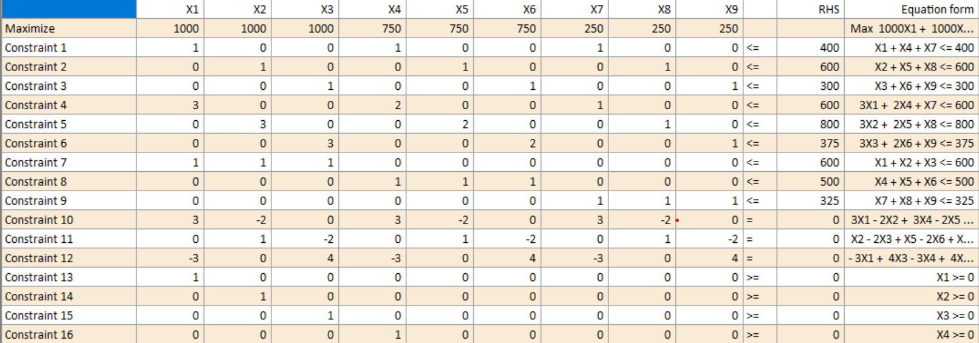

Solution::

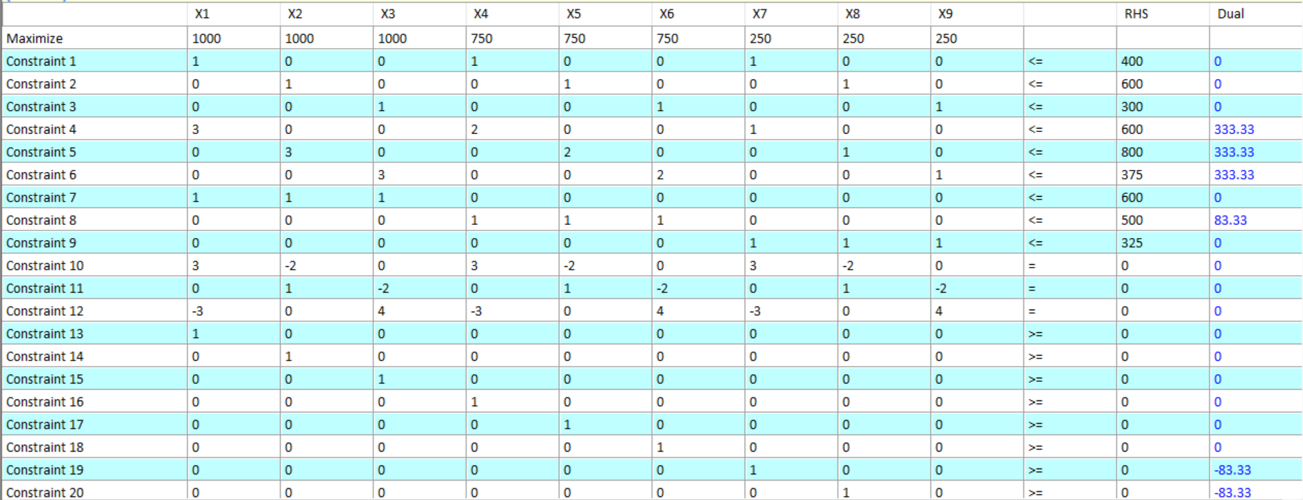 

1. **Personnel Scheduling**

Equation::

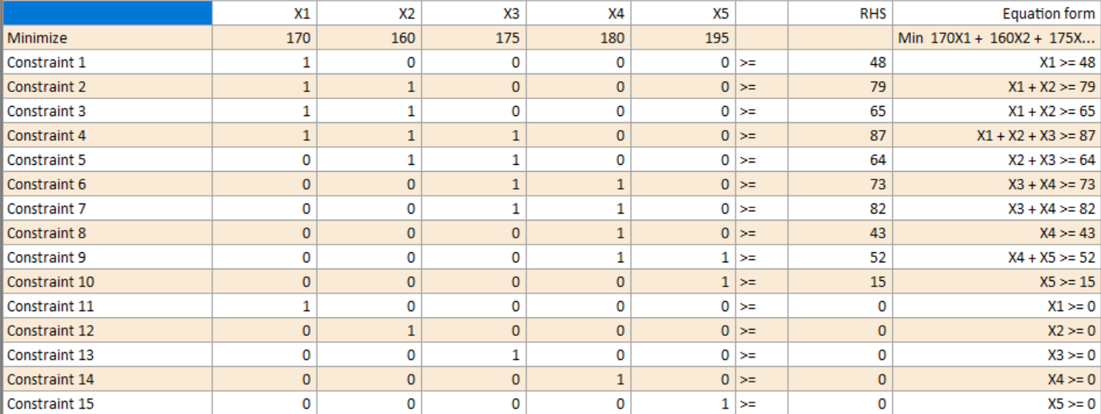

Solution::

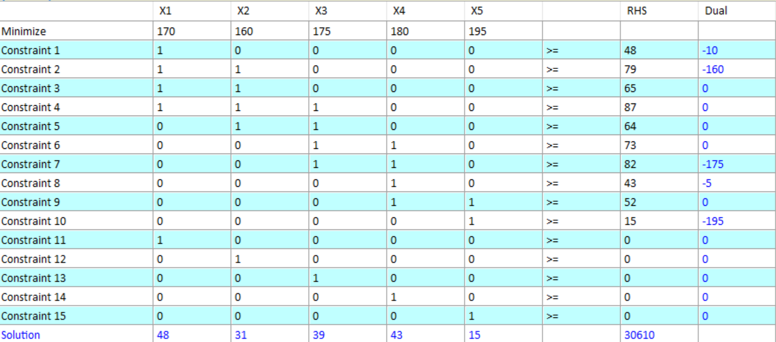

**PART B**







